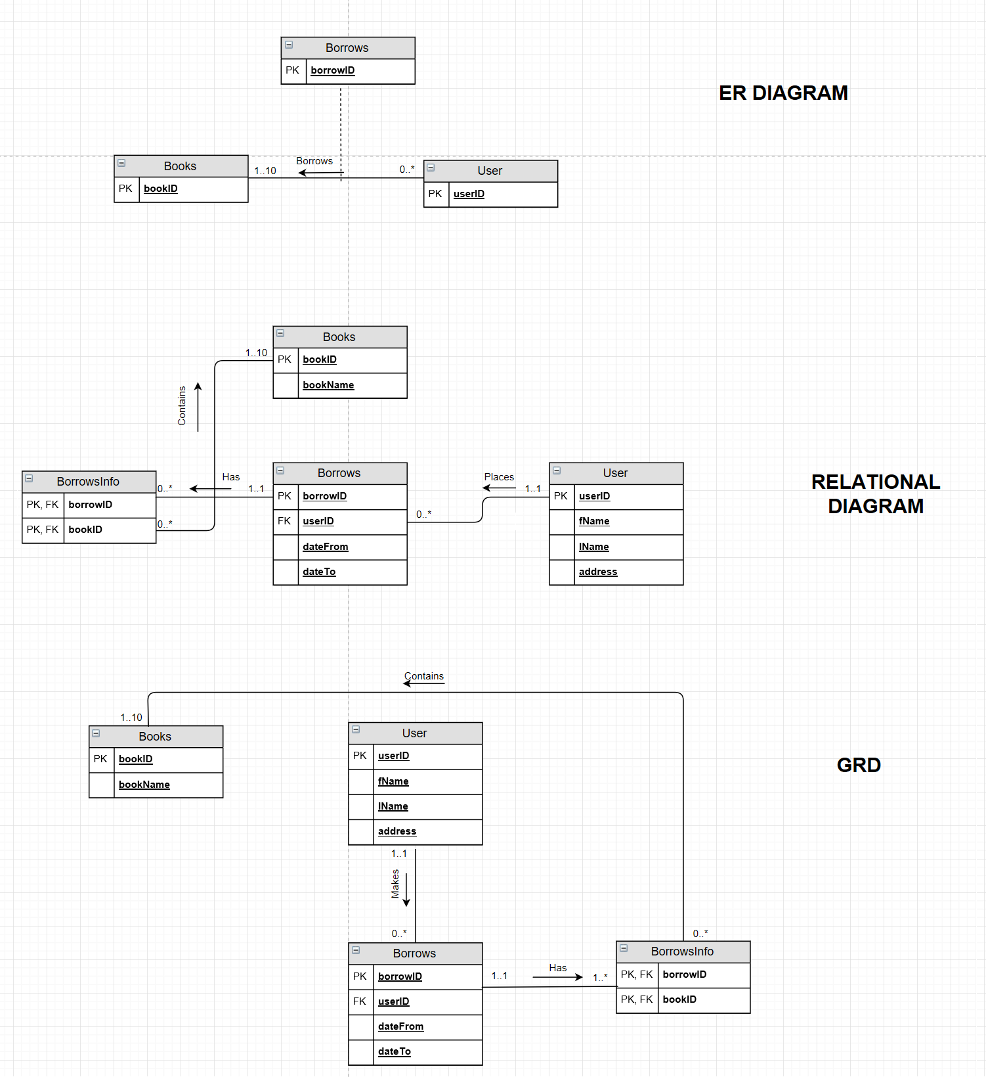

create table User
(
userID Int,
firstName varchar(50),
lastName varchar(50),
addressOF varchar(50),
PhoneNumber varchar(50),
CONSTRAINT User_PK PRIMARY KEY(userID)
)

create table Books
(
bookID Int,
bookName varchar(50),
CONSTRAINT Books_PK PRIMARY KEY(booksID)
)

create table Borrows
(
borrowID int,
userID int,
firstName varchar(50),
lastName varchar(50),
dateFrom date,
dateTo date,
CONSTRAINT Borrows_pk PRIMARY KEY(borrowID)
CONSTRAINT User_fk FOREIGN KEY(userID) REFERENCES User
)

create table BorrowsInfo
(
borrowID int,
bookID int
CONSTRAINT OrderDetail_pk PRIMARY KEY(borrowID, bookID),
CONSTRAINT Borrows_fk FOREIGN KEY(borrowID) REFERENCES Borrows,
CONSTRAINT book_fk FOREIGN KEY(bookID) REFERENCES Books
)

